NET731 – Networking
Week 7 Practical: Monitoring Setup
17–23 April | Total Marks: 10
Student Name: | Rayner Marsh
Student ID: | 20240179
Submission Date: | 23 April 2023
Azure Subscription ID: | 20240179@ctucareer.co.za

Learning Outcomes
By the end of this practical, you should be able to:
- Enable and configure Azure Monitor on virtual machine and network resources
- Navigate the Azure Monitor interface to locate and interpret key metrics
- Identify normal versus abnormal performance baselines for CPU, network, and disk
- Produce a structured monitoring report with supporting evidence

Overview
This week you will configure Azure Monitor across the cloud environment you have been building throughout the semester. Azure Monitor is the central platform for collecting, analysing, and acting on telemetry from your Azure resources. Effective monitoring is not simply about enabling tools — it requires understanding what you are measuring and why it matters.

You are expected to make decisions, explore the interface, and think critically about what you observe. Screenshots must clearly show your own Azure environment — generic or placeholder images will not be accepted.

Before You Begin — Prerequisites
Ensure your VM from previous weeks is running and accessible.
Your Virtual Network (VNet) and Network Security Group (NSG) from Week 5 should be in place.
You will need Contributor access to your Azure resource group.
Allow 10–15 minutes for monitoring data to populate after enabling Azure Monitor.

Task 1 — Enable Azure Monitor (4 Marks)
Azure Monitor needs to be enabled on individual resources before it can collect data. This task covers both your virtual machine and the network resources in your environment.

Task 1.1 — Enable Monitoring on Your Virtual Machine (2 Marks)
Navigate to your virtual machine in the Azure Portal and locate the Monitoring section in the left-hand menu. You will find several sub-options here — explore them before enabling anything.

Think Before You Click
What is the difference between 'Insights' and 'Diagnostics settings' for a VM?
What data will be collected once you enable monitoring? Where is it stored?
Does enabling monitoring have any cost implications you should be aware of?

Once you have explored the options, enable VM Insights or Diagnostics for your virtual machine. Configure it to collect at minimum: CPU metrics, memory (if supported), and disk I/O.

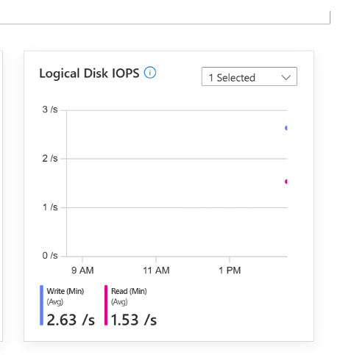
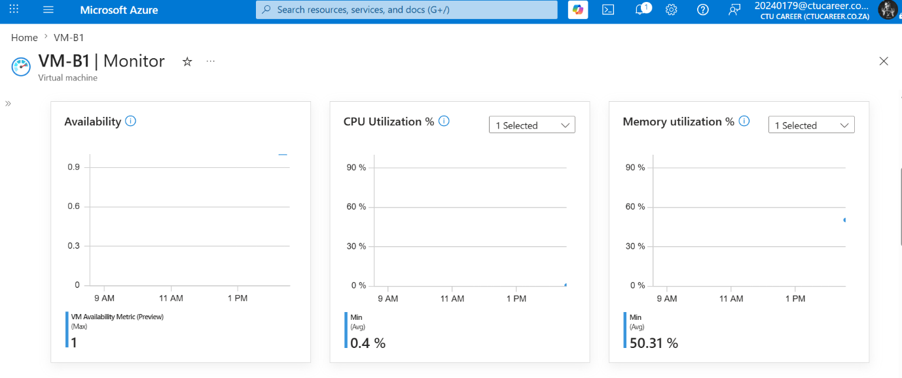
[ Screenshot: Azure Monitor enabled on VM — show the Monitoring blade confirming activation ]
Insert screenshot here

Describe in 2–3 sentences what you enabled and where the collected data will be stored:

Your response: I enabled Azure Monitor for the virtual machine (VM-B1) to collect and display performance metrics such as CPU utilization, memory usage, availability, and logical disk IOPS. The monitoring data collected by Azure Monitor is stored in Azure Monitor Metrics and can also be sent to a Log Analytics workspace for long-term storage, analysis, and alerting.

Task 1.2 — Enable Monitoring on Network Resources (2 Marks)
Repeat the process for your network resources. Both your NSG and your VNet support diagnostic settings.

Consider the following before proceeding:
- What specific log categories are available for an NSG? Which ones would be most useful in a security context?
- What is a Log Analytics Workspace, and why might you need one to proceed?
- If you do not already have a Log Analytics Workspace, you will need to create one — consider which region is appropriate.

[ Screenshot: Diagnostic settings enabled on NSG — show categories selected and destination ]
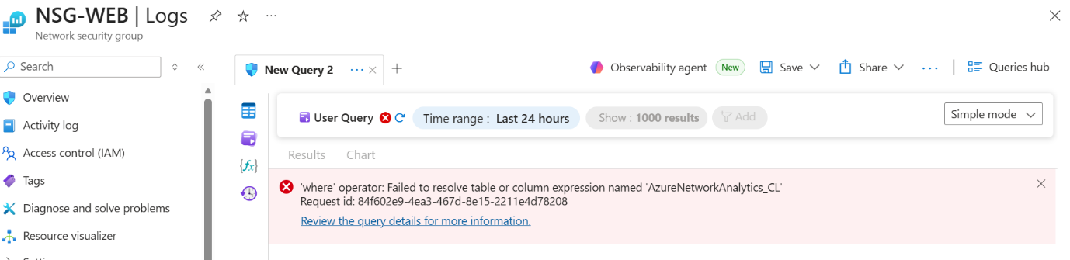Insert screenshot here

[ Screenshot: Diagnostic settings 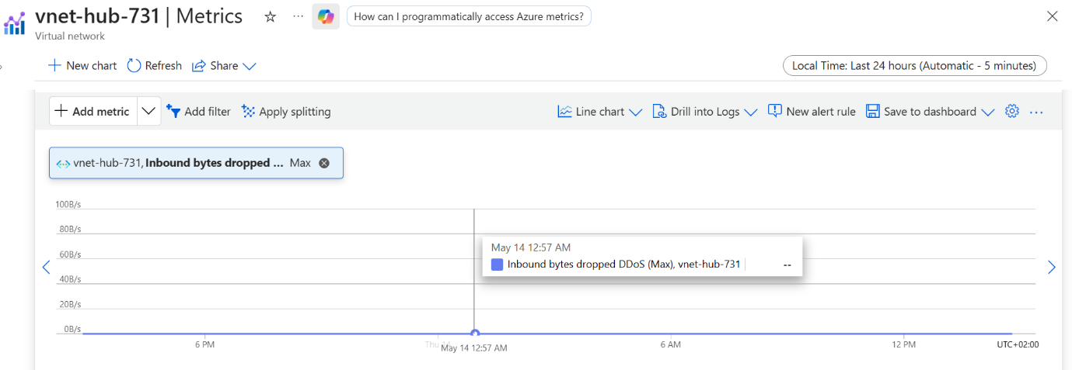on VNet or additional network resource ]
Insert screenshot here

Task 2 — Review Key Metrics (3 Marks)
Now that monitoring is enabled, you will use Azure Monitor's Metrics Explorer to observe and interpret the data being collected. Generating some load on your VM before taking screenshots will produce more meaningful graphs.

Generating Test Load (Optional but Recommended)
On Linux VMs: the 'stress' tool can simulate CPU and I/O load.
On Windows VMs: Task Manager's 'New Task' can run a CPU-intensive process.
Even browsing the web or installing packages from within the VM will generate measurable network activity.
Allow a few minutes after generating load before capturing screenshots.

Task 2.1 — CPU Metrics (1 Mark)
Open Azure Monitor > Metrics and select your VM as the scope. Explore the available metrics before choosing one to display.

- Select an appropriate time range that shows meaningful data (consider: what time range makes sense for a lab exercise?)
- Identify which metric reflects actual CPU usage — consider why there might be more than one CPU-related metric
- Add annotations or use the pin feature to highlight any interesting patterns you observe

[ Screenshot: CPU metrics 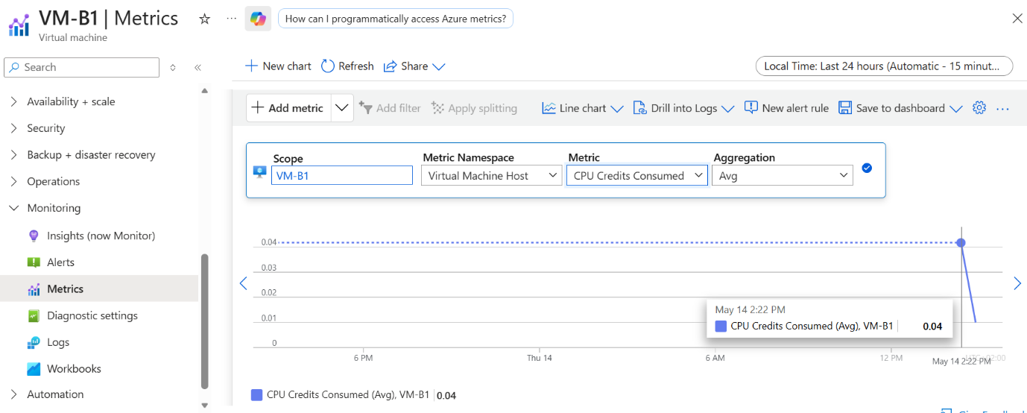chart — VM scope, showing usage over a meaningful time period ]
Insert screenshot here

In 1–2 sentences, describe what the CPU metric is showing and whether the values appear expected for your workload:
The CPU metric shows very low CPU Credits Consumed usage on the VM, averaging around 0.04, which indicates that the virtual machine is under a light workload with minimal processing demand. These values appear normal and expected for a VM that is mostly idle or running only basic background tasks.

Task 2.2 — Network Metrics (1 Mark)
Still in Metrics Explorer, change the metric to observe network throughput. You should investigate both inbound and outbound traffic.

- What is the unit of measurement for the network metric you selected? Is it what you expected?
- Can you display both Network In and Network Out on the same chart? How would you do this?

[ Screenshot: Net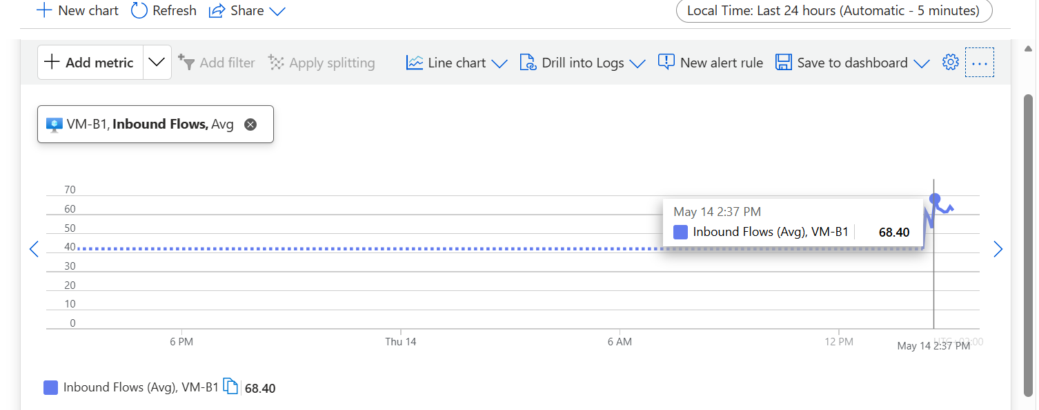work metrics ch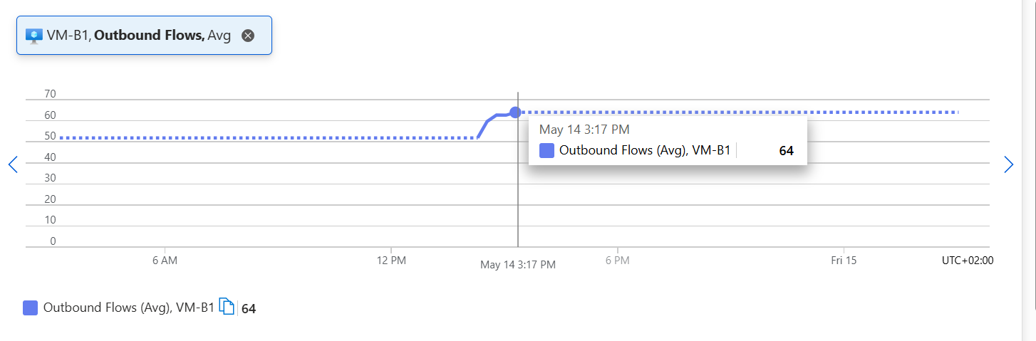art — showing inbound and/or outbound traffic ]
Insert screenshot here

Note any observations about the network traffic pattern you can see:
The network traffic metrics show moderate inbound and outbound flow activity, with inbound traffic averaging about 68.40 and outbound traffic around 64. This suggests that the VM is actively communicating over the network, but the traffic levels appear stable without sudden spikes or unusual patterns.

Task 2.3 — Disk Metrics (1 Mark)
Finally, explore the disk-related metrics for your VM. Azure exposes separate metrics for disk reads and disk writes.

- Locate both Disk Read Bytes and Disk Write Bytes (or equivalent metrics in your VM configuration)
- Consider: during what activities would you expect disk write activity to be high?

[ Screenshot: D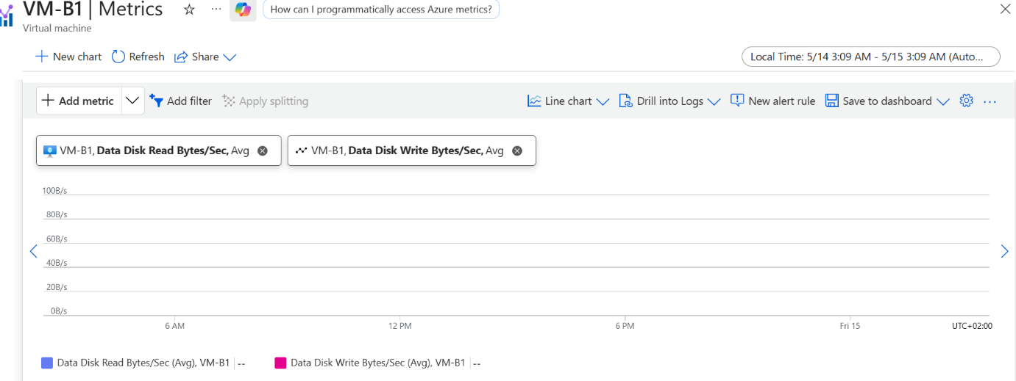isk metrics chart — showing read and/or write activity ]
Insert screenshot here

Describe in 1–2 sentences what the disk metrics reveal about your VM's activity:
The Disk metrics show the VM’s data disk read and write activity overtime. The graph appears flat which means there was no disk activity.

Task 3 — Document Your Monitoring Setup (3 Marks)
Monitoring documentation is a critical deliverable in professional environments. A future administrator — or your future self — should be able to understand your setup from the document alone.

Task 3.1 — Monitoring Summary (2 Marks)
Write a structured summary of your monitoring configuration. Your summary should cover all three areas below. Aim for clarity and precision — this is professional technical documentation.
I monitored a VM's CPU, disk space and Its network traffic with Azure Monitors metric tool. Also monitored a VNET using azure monitor's metric tool, I chose a metric randomly to see if it would have any traffic on it, Also looked at NSG logs

Metric Observations

The metrics seemed normal, although I had limited data to work with

Resources Monitored
List each Azure resource you have enabled monitoring on, specifying the monitoring method used (e.g., VM Insights, Diagnostic Settings) and what data each resource is collecting:

Data Retention and Storage
Where is your monitoring data stored? What retention period applies? How would you access historical data older than the default retention window?

Metric Observations
Summarise what you observed across the three metrics reviewed in Task 2. Were any values unexpected? What might cause anomalies in these metrics in a production environment?

Task 3.2 — Extension: Configure an Alert Rule (1 Bonus Mark)
Extension Task
This task is optional but provides an opportunity to demonstrate deeper understanding.
Configure at least one Azure Monitor Alert Rule on your VM or network resource.
The alert should have a meaningful threshold — for example, triggering when CPU exceeds 80% for 5 minutes.
Document your alert logic: what condition triggers it, what action does it take, and why you chose that threshold.

[ Screenshot: Confi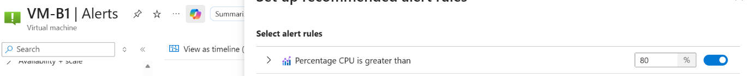gured al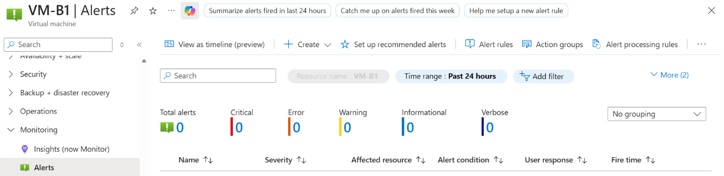ert rule — show condition, threshold, and action group ]
Insert screenshot here

Explain the alert rule you configured and the reasoning behind your chosen threshold:
I’ve set up an alert to notify me when yhe CPU percentage is greater than 80%.

Reflection Questions
Answer these questions thoughtfully. There are no single correct answers — markers are looking for evidence of understanding and critical thinking.

Reflection Question | Your Response
Why is monitoring important in a cloud environment? How does it differ from monitoring on-premises infrastructure? | It is important because you don’t physically own the hardware. You are responsible for the performance, security and cost of resources.  Unlike on-premises, cloud monitoring focuses on virtual resources, dynamic scaling, and ties directly to usage costs.
What is the difference between a metric and a log in Azure Monitor? When would you use each? | Metrics are numeric values over time for health and performance, like CPU % or request count. Use for real-time alerts and dashboards.  Logs are detailed event records for diagnostics and analysis. Use for root cause investigation and historical searches.  Metrics tell you what happened; logs tell you why.
If your VM showed consistently high CPU usage (above 90%) every day at 2am, what steps would you take to investigate? | Verify the pattern in Azure Monitor metrics.  Check for scheduled tasks, backups, or jobs running at 2am.  Query Log Analytics to find which process used CPU.  If needed, optimize the job, resize the VM, or reschedule it.
How could monitoring data be used to make cost-optimisation decisions in Azure? | Use metrics to identify underused VMs for downsizing, find idle resources to delete, and tune auto scale rules. Use logs to analyse storage access for tiering. Historical usage data also helps decide when to buy Reservations or Savings Plans for discounts.

Marking Criteria
Use this table to check your submission before submitting.

Task | Marks | Evidence Required
1.1 Enable Azure Monitor on VM | 2 | Screenshot of Monitor enabled on VM resource
1.2 Enable Monitoring on Network Resources | 2 | Screenshot showing NSG/VNet diagnostics
2.1 CPU Metrics Review | 1 | Screenshot of CPU usage chart with annotations
2.2 Network Metrics Review | 1 | Screenshot of network in/out metrics
2.3 Disk Metrics Review | 1 | Screenshot of disk read/write metrics
3.1 Monitoring Documentation | 2 | Written summary with all screenshots included
3.2 Alert Configuration (Extension) | 1 | Screenshot of configured alert rule
TOTAL | 10

Submission Checklist
All screenshot placeholders have been replaced with real screenshots from your Azure environment.
Each screenshot clearly shows your resource names and Azure subscription context.
Written responses are your own words — not copied from documentation.
Reflection questions have been answered with evidence of understanding.
The document has been saved as a .docx or .pdf and submitted via the course portal.

Useful References
The following official documentation may help — but always explore the Azure Portal first before consulting documentation:

- Azure Monitor overview — docs.microsoft.com/azure/azure-monitor/overview
- Enable VM Insights — docs.microsoft.com/azure/azure-monitor/vm/vminsights-enable-overview
- Metrics Explorer — docs.microsoft.com/azure/azure-monitor/essentials/metrics-getting-started
- Diagnostic settings — docs.microsoft.com/azure/azure-monitor/essentials/diagnostic-settings
- Azure Monitor Alerts — docs.microsoft.com/azure/azure-monitor/alerts/alerts-overview

Tip: The Azure Portal's built-in 'Learn more' links on each blade are often the fastest route to relevant documentation.

